

The International Committee on Taxonomy of Viruses

Taxonomy Proposal Form, 2024

**Part 1a: Details of taxonomy proposals**

|  |  |  |
| --- | --- | --- |
| **Title:** | Create 1 new family ‘Nipumfusiviridae’ with 4 genera and 10 species for archaeal viruses | |
| **Code assigned:** | 2024.003A.N.v1,Nipumfusiviridae_newfam |

|  |  |  |  |
| --- | --- | --- | --- |
| **Author(s), affiliation and email address(es):** | | | |
| **Name** | **Affiliation** | **Email address** | **Corresponding author(s)** X |
| Yimin Ni | College of Food Science and Technology, Shanghai Ocean University, Shanghai, China | Nemo.ni@outlook.com | X |
| Tianqi Xu | College of Food Science and Technology, Shanghai Ocean University, Shanghai, China | xutianqi98@163.com |  |
| Shuling Yan | College of Food Science and Technology, Shanghai Ocean University, Shanghai, China | shuling.yan@biologie.uni-marburg.de |  |
| Lanming Chen | Entwicklungsgenetik und Zellbiologie der Tiere, Philipps-Universität Marburg, Marburg, Germany | lmchen@shou.edu.cn |  |
| Yongjie Wang | College of Food Science and Technology, Shanghai Ocean University, Shanghai, China | yjwang@shou.edu.cn |  |

**Part 1b: Taxonomy Proposal Submission**

|  |  |  |  |
| --- | --- | --- | --- |
| **ICTV Subcommittee:** | | | |
| Animal DNA Viruses and Retroviruses |  | Bacterial viruses |  |
| Animal minus-strand and dsRNA viruses |  | Fungal and protist viruses |  |
| Animal positive-strand RNA viruses |  | Plant viruses |  |
| Archaeal viruses | **X** | General - |  |

|  |
| --- |
| **List the ICTV Study Group(s) that have seen or have been involved in creating this proposal:** |
| Mart Krupovic |

|  |  |  |  |
| --- | --- | --- | --- |
| **Optional – complete only if formally voted on by an ICTV Study Group:** | | | |
| **Study Group** | **Number of members** | | |
| **Votes in support** | **Votes against** | **No vote** |
|  |  |  |  |
|  |  |  |  |

|  |  |
| --- | --- |
| **Submission date:** | 20/05/2024 |

**Part 1c: Feedback from ICTV Executive Committee (EC) meeting**

|  |  |
| --- | --- |
| **Executive Committee Meeting Decision code:** | **X** |
| A – Accept |  |
| Ac – Accept subject to revision by relevant subcommittee chair. No further vote required |  |
| U – Accept without revision but with re-evaluation and email vote by the EC |  |
| Uc – Accept subject to revision and re-evaluation and email vote by the EC |  |
| Ud – Deferred to the next EC meeting, with an invitation to revise based on EC comments |  |
| J - Reject |  |
| W - Withdrawn |  |

|  |
| --- |
| **Comments from the Executive Committee:** |
|  |

**Part 1d: Revised Taxonomy Proposal Submission**

|  |
| --- |
| **Response of proposer:** |
|  |

|  |  |
| --- | --- |
| **Revision date:** | DD/MM/YYYY |

**Part 3:** **TAXONOMIC PROPOSAL**

|  |
| --- |
| **Name of accompanying Excel module:** |
| 2024.003A.N.v1,Nipumfusiviridae_newfam.xlsx |

|  |  |  |  |
| --- | --- | --- | --- |
| **Taxonomic changes proposed:** | | | |
| Establish new taxon | **X** | Split taxon |  |
| Abolish taxon |  | Merge taxon |  |
| Move taxon |  | Promote taxon |  |
| Rename taxon |  | Demote taxon |  |
| Move and rename |  |

|  |  |  |
| --- | --- | --- |
| **Is any taxon name used here derived from that of a living person:** | | **N** |
| **Taxon name** | **Person from whom the name is derived** | **Attached X** |
|  |  |  |
|  |  |  |
|  |  |  |

|  |
| --- |
| **Abstract of Taxonomy Proposal:** |
| We propose a new family for Nitrosopumilaceae virus NYM1 and its relatives, the ‘Nipumfusiviridae’ (‘Ni’ and ‘pum’ for having sequence features similar to archaea from the family *Nitrosopumilaceae* and for being the deduced host; ‘fusi’ after the Latin word meaning spindles for the possible morphology). The four proposed genera are named ‘Yangshanfusivirus’, ‘Terrafusivirus’, ‘Marefusivirus’, and ‘Baiafusivirus’ after their original sampling sites, and species names are given based on the sampling locations. To be classified within this proposed family, the new members should share a minimum of 30% of average amino acid identity (AAI) with the virus genomes classified within ‘Nipumfusiviridae’ and share a minimum set of homologous proteins including the MCP, and the ATPase. |

|  |
| --- |
| **Text of Taxonomy proposal:** |
| The genome of a putative *Nitrosopumilaceae* archaeal virus with a hypothesized spindle-shaped morphology was identified in the Yangshan Harbour metavirome from the East China Sea (Ni et al., 2024). This discovery was made through sequence homology comparison with *Nitrosopumilaceae* archaea genomes and structural analysis of the major capsid protein (MCP) with known spindle-shaped viruses (Han et al., 2022; Wang et al., 2022). Additionally, 10 closely related viruses were identified in the IMG/VR v4 UViG environmental dataset.  The alignment of the genomes revealed multiple sets of homologous proteins shared amongst Nitrosopumilaceae virus NYM1 (referred to as NYMAG-47 in the original research article) and its 10 relatives (Figure 1). One of the homologous proteins with a length of 89 amino acid residues in Nitrosopumilaceae virus NYM1 showed a remote homology to the MCP (VP1) of Sulfolobus spindle-shaped virus 19 (SSV19), during the HHpred and HMM searches with limited confidence (probability 75.4%). Subsequently, the structure of the suspected MCP of Nitrosopumilaceae virus NYM1 was predicted and compared to the cryo-EM structures of the SSV19 VP1, Sulfolobus monocaudavirus 1 (SMV1) MCP, and Aeropyrum pernix bacilliform virus 1 (APBV1) MCP, resulting in significant matches with Z scores of 5.9, 4.3, and 3.5, respectively. These comparisons revealed that the suspected MCP of Nitrosopumilaceae virus NYM1 shared a curved α-harpin structure similar to the experimentally determined structure of MCPs of SSV19, SMV1 and APBV1 (Figure 2)(Han et al., 2022; Wang et al., 2022).  Nitrosopumilaceae virus NYM1 was predicted to be a virus infecting hosts of archaeal family *Nitrosopumilus* by iPHoP (Roux et al., 2023). Additionally, Nitrosopumilaceae virus NYM1 had a methyltransferase (Nitrosopumilaceae virus NYM1 ORF 15) sharing high identity (coverage: 97%; identity: 77%) with that encoded on a *Candidatus* Nitrosarchaeum limnium SFB1 contig. The other 10 virus genomes each encoded 2.5 ± 0.8 proteins sharing significant similarity (coverage ≥ 30%, identity ≥ 50%, e-value ≥1e-5) with proteins encoded by *Nitrosopumilus* strains on average.  Nitrosopumilaceae virus NYM1 had little sequence similarity to the known Nitrosopumilus spindle-shaped viruses (NSVs) despite sharing host from the same family and similar predicted virion morphology. Most of Nitrosopumilaceae virus NYM1 gene functions could not be predicted with conventional database comparison, including the MCP, which explains why it was not previously identified. Remote homology searches with HHblits annotated 52 proteins of Nitrosopumilaceae virus NYM1 to be of unknown functions, with three of them present in the conserved gene cluster shared amongst all relatives (Figure 1). ATPase found on these genomes (Figure 1) was shared as a putative core gene, and it was detected in all spindle-shaped viruses previously discovered, correlating to genome replication (Krupovic et al., 2014). The family B DNA polymerase of His1 and NSV1 was not detected in the genome of Nitrosopumilaceae virus NYM1, suggesting a different set of replicative genes amongst in this lineage.  The phylogenetic and phylogenomic analyses based on the MCPs and the whole-proteomes, respectively, both revealed a distinctly different lineage of Nitrosopumilaceae virus NYM1 and its 10 relatives in comparison to the known spindle-shaped archaeal viruses (Figure 4). It suggests that these viruses could be classified into a distinct taxon. All virus genome assemblies are found to possess direct terminal repeats, indicating the feature of a circular genome.  Even when these genomes share a cluster of genes with homology (Figure 1), there is little nucleotide sequence similarity shared amongst these genomes (less than 1% in some cases). For that reason, we provided a classification criterion based on mean AAI value other than nucleotide identity.  By considering the phylogenomic tree of whole-proteomes compared to known spindle-shaped viruses, the mean AAI value calculated across the 11 genomes, and the differences in protein clusters observed in Nitrosopumilaceae virus NYM1 and its 10 relatives (Figure 5), these genomes could be classified into four different genera within the same family.  **Demarcation criteria:**  To be classified within this proposed family, the new members should share a minimum of 30% of mean average amino acid identity (AAI) with the virus genomes classified within ‘Nipumfusiviridae’ and share a minimum set of homologous proteins including the MCP, and the ATPase.  To be classified within the same genera to be established in this proposal, the new members should share a minimum of 50% of mean AAI with members in the established genera and share a minimum set of homologous proteins including the MCP, and the ATPase.  To be classified within the same species to be established in this proposal, the new members should share a minimum of 95% of nucleotide identity with members in the established species.  These criteria are subject to change should the functions of the genes shared amongst the same taxonomic rank be annotated from further research.  **Etymology of the virus name:**  The family name ‘Nipumfusiviridae’ is given based on deduced host and virion morphology (‘Ni’ and ‘pum’ for having *Nitrosopumilaceae* being the deduced host; ‘fusi’ after the Latin word meaning spindles for the possible morphology).  The four genera are given prefixes based on original sampling sites. ‘Yangshan’ after Yangshan Harbor in China; ‘Terra’ after Italian word ‘terra’ meaning soil; ‘Baia’ after Italian word ‘baia’ meaning bay; and ‘Mare’ after Italian word ‘mare’ meaning sea (‘Yangshanfusivirus’, ‘Terrafusivirus’, ‘Marefusivirus’, and ‘Baiafusivirus’).  Species epithets are based on the sampling locations ('pacificense': Marine waters of Pacific Ocean; 'tennesseense': Rhizosphere of Tennessee; 'helgoense': Pelagic waters of Helgoland; ‘jervisense': Inlet of Jervis; 'delawarense': Coastal water of Delaware Bay; 'chesapeakense': Coastal water of Chesapeake Bay; 'michiganense': Rhizosphere of Michigan; 'columbiaense': Estuarine of Columbia River; 'montereyense': Marine water of Monterey Bay; 'mimetica' after Italian word 'mimetico' meaning camouflage). |

|  |
| --- |
| **References:** |
| Han, Z., Yuan, W., Xiao, H., Wang, L., Zhang, J., Peng, Y., Cheng, L., Liu, H., & Huang, L. (2022). Structural insights into a spindle-shaped archaeal virus with a sevenfold symmetrical tail. Proceedings of the National Academy of Sciences of the United States of America, 119(31). https://doi.org/10.1073/pnas.2119439119  Krupovic, M., Quemin, E. R. J., Bamford, D. H., Forterre, P., & Prangishvili, D. (2014). Unification of the Globally Distributed Spindle-Shaped Viruses of the Archaea. Journal of Virology, 88(4), 2354–2358. https://doi.org/10.1128/JVI.02941-13/ASSET/1368CCFA-D609-412B-990F-AB2A200BA7D2/ASSETS/GRAPHIC/ZJV9990986680004.JPEG  Ni, Y., Xu, | Tianqi, Yan, S., Chen, | Lanming, & Wang, Y. (2024). Hiding in plain sight: The discovery of complete genomes of 11 hypothetical spindle-shaped viruses that putatively infect mesophilic ammonia-oxidizing archaea. Environmental Microbiology Reports. https://doi.org/10.1111/1758-2229.13230  Roux, S., Camargo, A. P., Coutinho, F. H., Dabdoub, S. M., Dutilh, B. E., Nayfach, S., & Tritt, A. (2023). iPHoP: An integrated machine learning framework to maximize host prediction for metagenome-derived viruses of archaea and bacteria. PLOS Biology, 21(4), e3002083. https://doi.org/10.1371/JOURNAL.PBIO.3002083  Wang, F., Cvirkaite-Krupovic, V., Vos, M., Beltran, L. C., Kreutzberger, M. A. B., Winter, J. M., Su, Z., Liu, J., Schouten, S., Krupovic, M., & Egelman, E. H. (2022). Spindle-shaped archaeal viruses evolved from rod-shaped ancestors to package a larger genome. Cell, 185(8), 1297-1307.e11. https://doi.org/10.1016/J.CELL.2022.02.019 |

|  |
| --- |
| **Tables, Figures:** |



FIGURE 1: Proteins producing identity shared between Nitrosopumilaceae virus NYM1 recruited genomes and NSV1 included for having putatively similar hosts. (A) The identity of proteins shared amongst all genomes besides NSV1 is aligned and coloured to differentiate different protein functions. Arrow orientation on the genomes indicates the ORF translation direction. Genomes are positionally aligned by the putative MCP of Nitrosopumilaceae virus NYM1. (B) Genomic map of Nitrosopumilaceae virus NYM1. Functions predicted by the conserved proteins in Nitrosopumilaceae virus NYM1 are labelled, and some functions similar to that of the genes present in the NSV1 are also labelled. MCP, major capsid protein; MTase: DNA methyltransferase; RHH: ribbon-helix–helix; HTH: helix-turn-helix.

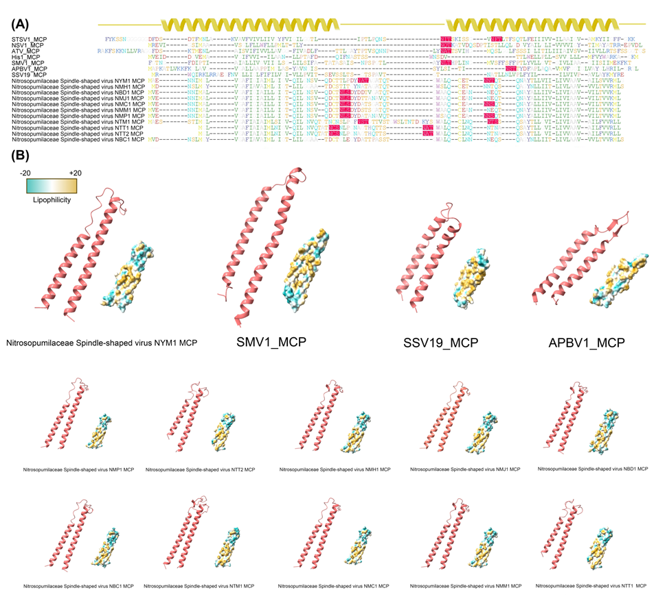

FIGURE 2: The MCP sequences and structures of Nitrosopumilaceae virus NYM1 and related MCPs. (A) The sequence alignment between the MCPs of this study and the representatives of known spindle-shaped viruses. Suspected N-glycosylation sites are highlighted in red. The secondary structure is shown by the ribbons to represent the two hydrophobic α-helixes predicted. (B) Predicted protein structures and lipophilicity profiles of Nitrosopumilaceae virus NYM1, three spindle-shaped viruses studied previously at high resolution, and 10 relatives of Nitrosopumilaceae virus NYM1. The two α-helixes are as shown in the ribbon model, and the sphere model indicates the lipophilicity.

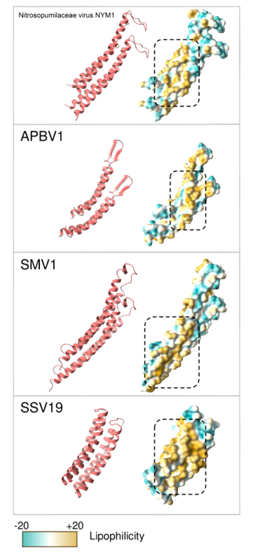

FIGURE 3: MCP docking prediction of Nitrosopumilaceae virus NYM1 and 3 known spindle-shaped viruses presented in ribbon model and sphere model. The hydrophobic interaction surfaces are framed with dashed boxes.

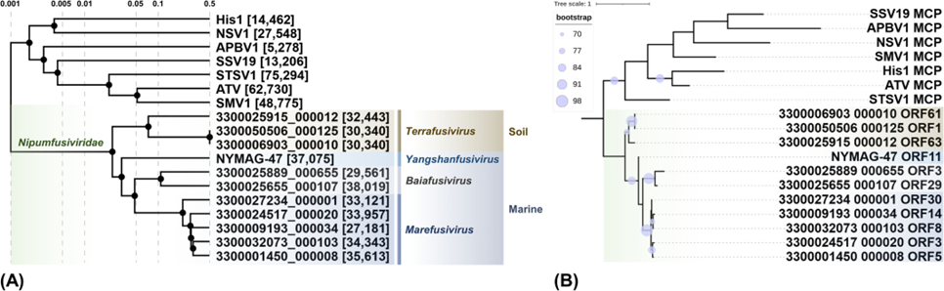

FIGURE 4: The ViPTree proteomic tree demonstrating the phylogeny of Nitrosopumilaceae virus NYM1, recruited relatives, and known spindle-shaped archaeal viruses. The proposed four new genera are shown in different colours at the end of the branches. (A) Whole genome proteomic tree. The Sg value is labelled on the top, and the proposed taxonomy and sequenced sample origin of Nitrosopumilaceae virus NYM1 and its relatives are included. Lengths of each virus genome are shown in the square bracket (bp). (B) Major capsid protein tree. Only nodes with bootstrap values higher than 70% are shown. Genome names used in the tree and corresponding virus name: 3300025915_000012: Nitrosopumilaceae Spindle-shaped virus NTM1; 3300050506_000125: Nitrosopumilaceae Spindle-shaped virus NTT1; NYMAG-47: Nitrosopumilaceae Spindle-shaped virus NYM1; 3300006903_000010: Nitrosopumilaceae Spindle-shaped virus NTT2; 3300025889_000655: Nitrosopumilaceae Spindle-shaped virus NBC1; 3300025655_000107: Nitrosopumilaceae Spindle-shaped virus NBD1; 3300027234_000001: Nitrosopumilaceae Spindle-shaped virus NMC1; 3300024517_000020: Nitrosopumilaceae Spindle-shaped virus NMJ1; 3300009193_000034: Nitrosopumilaceae Spindle-shaped virus NMH1; 3300032073_000103: Nitrosopumilaceae Spindle-shaped virus NMM1; 3300001450_000008: Nitrosopumilaceae Spindle-shaped virus NMP1

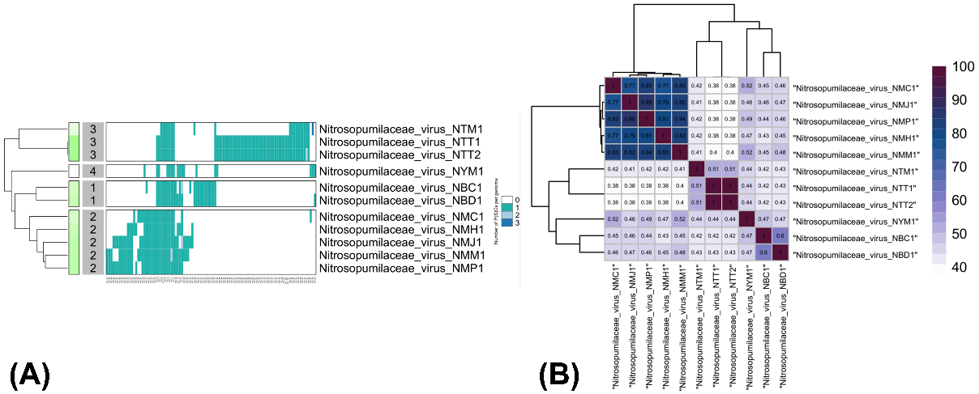FIGURE 5: Hierarchical clustering of 11 genomes based on (A): protein clusters and (B): pairwise average genome AAI. (A), Color blocks indicating proteins of the same cluster from different genomes are arranged on the same column. Blocks of different color indicate different numbers of proteins of the same cluster encoded on the same genome as stated by the legend on the right of the graph; (B), Numbers in the blocks indicate the pairwise mean AAI value of the two genomes from the same column and row.